El Paso County is home to Colorado’s largest population of children ages 0-5, estimated to be 46,863, and growing. El Paso County’s total childcare spots total 17,452, enough seats for 37.4% of this population of children.
The majority of El Paso County is a childcare desert, with limited access and options for most families. More families than ever are seeking childcare as an option as the cost of living continues to increase, and both new and existing providers in El Paso County are in a unique position to expand care to thousands of families.
We estimate from the high demand for UPK in El Paso County that roughly 70% of families are interested in childcare. Based on this assumption, to meet this need, El Paso County needs 16,935 more seats.
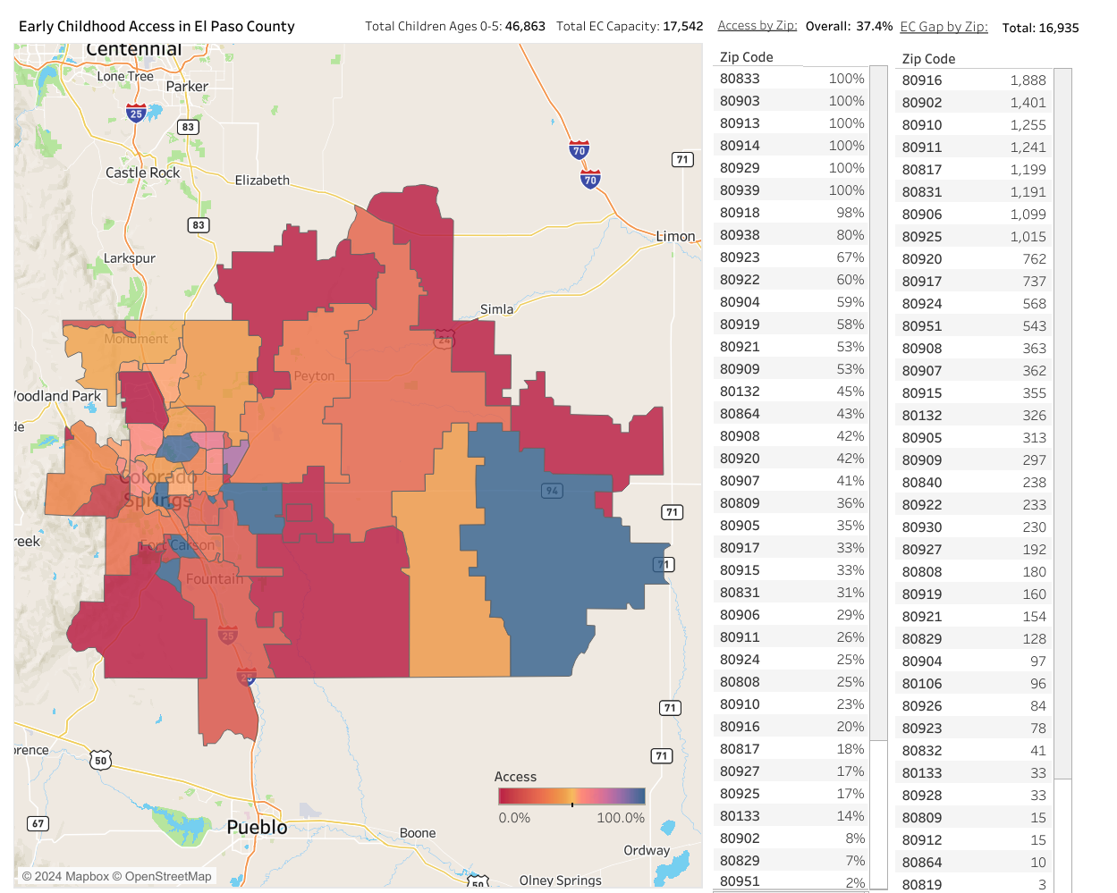

Colorado Springs’ south/southeast and the east/northeast areas, zip codes 80916, 80902, 80910, 80911, 80817, 80831, 80906, 80925, 80920, & 80917, contain the highest concentrations of children ages 0-5 and currently have some of the lowest access for these children. Improving access in these areas, and in most areas of El Paso County, would greatly benefit children and families and open exciting opportunities for providers.

