**Guide: How to Complete The Program Set Up Form**

## **In this Guide, as well as the associated example video,** **we will walk through the Program Set Up Form using the example “Test Provider 8”.**

## **Example Programs: As we walk through the program set up for “Test Provider 8”, we will create the 5 programs Below:**

Provider Program Set Up Form – Programs for Test Provider 8

|  |  |  |  |  |
| --- | --- | --- | --- | --- |
| **Program Duration** | **Program Language** | **# of Non-IEP Seats** | **# of IEP Seats** | **Total Seats** |
| Full-Time 30-40 Hours per week | English | 30 | 10 | 40 |
| Full-Time 30-40 Hours per week | Spanish | 18 | 2 | 20 |
| Half-Day AM: 15 Hours per week | Other Native Language | 18 | 2 | 20 |
| Half-Day AM: 15 Hours per week | Dual Language | 18 | 2 | 20 |
| Other: 18 Hours per week | English | 14 | 6 | 20 |

## **Within the Provider Program Set Up Form, we will:**

1. Understand the information needed to complete the form
2. Complete the provider kindergarten eligibility date and program overview questions
3. Add programs to each provider location, including language of instruction, number of non-IEP seats, and number of IEP seats.
4. Indicate the Authorized Signer for the location we will set up
5. Understand the next steps after submitting the form

## **1. Understand the information needed to complete the form**

On the first screen, we see the below information indicating what we need to complete this form; Please see below.

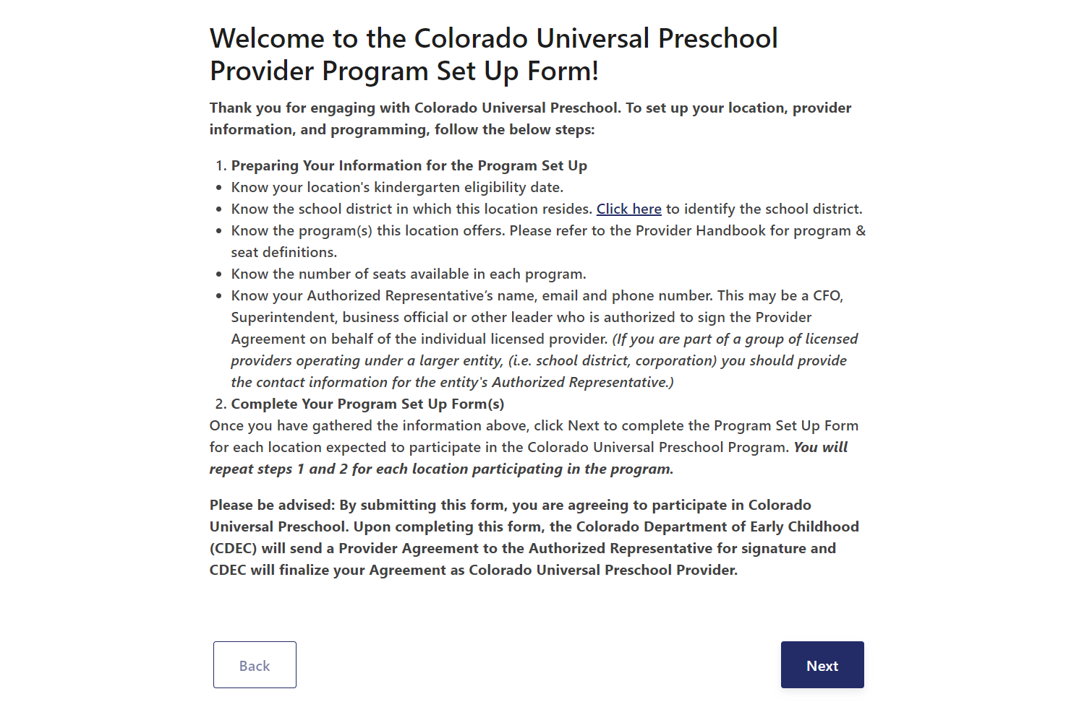

## **2. Complete the provider kindergarten eligibility date and program overview questions**

The following screen asks us to verify the provider Kindergarten Eligibility date. On this screen, we can select an eligibility date of 10/1, or an eligibility date of the District where this facility is located. This helps the system understand the age eligibility dates.

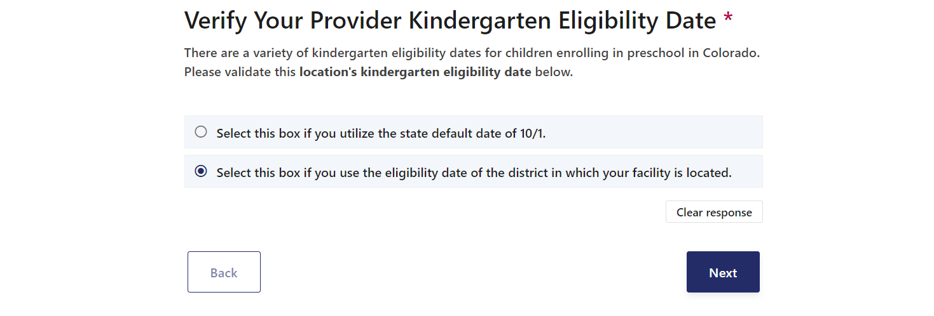

Next, we can indicate the school district where this facility is located through the drop down menu.

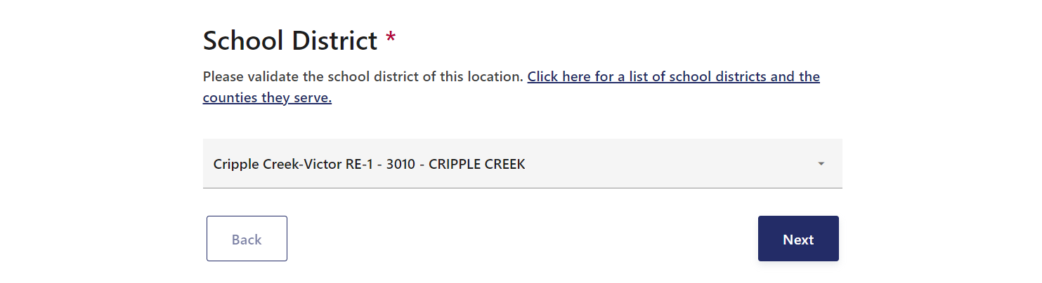

After indicating the school district where the facility is located, please select all of the program overview requirements that apply to this location.

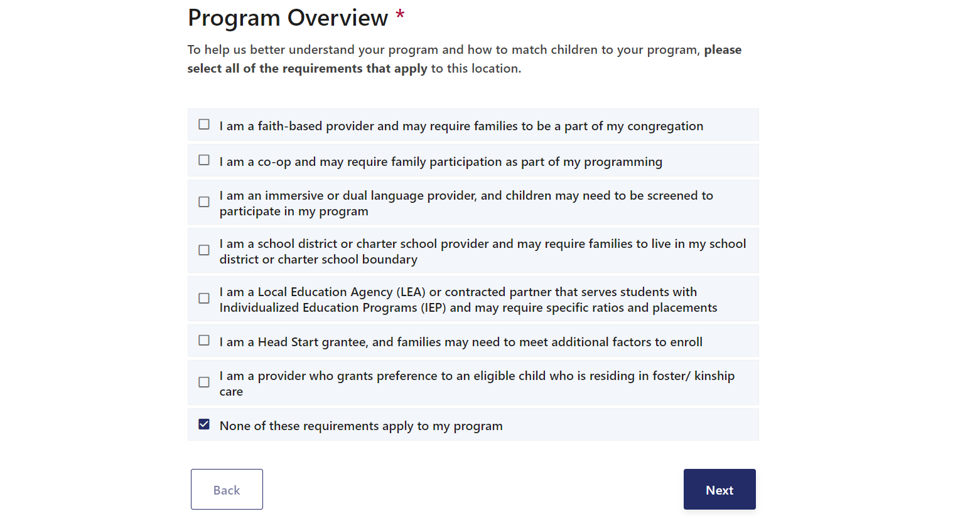

## 

## **3. Add programs to each provider location, including language of instruction, number of non-IEP seats, and number of IEP seats**

At this point in the Program Set Up Form, we can add our programs. In our example table at the beginning of this guide, we will add programs for three different program duration types:

* Full-Time 30-40 Hours per week
* Half-Day AM: 15 Hours per week
* Other: 18 Hours per week

Based on the programs we support with this location, we will add the below program durations:

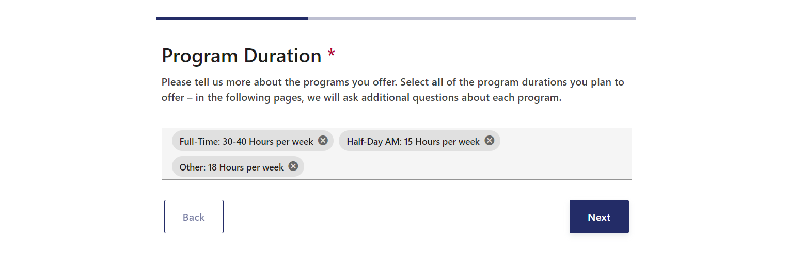

The resulting screens are based on these Program Duration Selections. First, indicate the Language(s) of instruction for the first program, “Full-Time: 30-40 Hours per week”. This example location offers two different language programs for the “Full-Time: 30-40 Hours per week” Program Duration. The screenshot below reflects these selections:

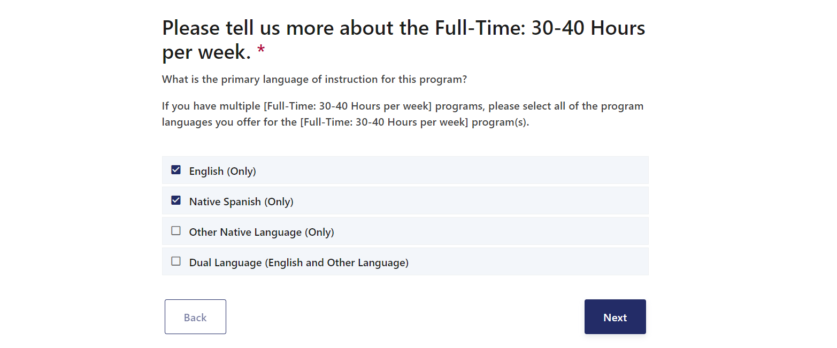

Based on the combination of Program Durations and Language of Instruction, we will add the number of seats for each program.

The “Full-Time: 30-40 Hours per week - English (Only)” program has 30 non-IEP seats, and 10 IEP seats.

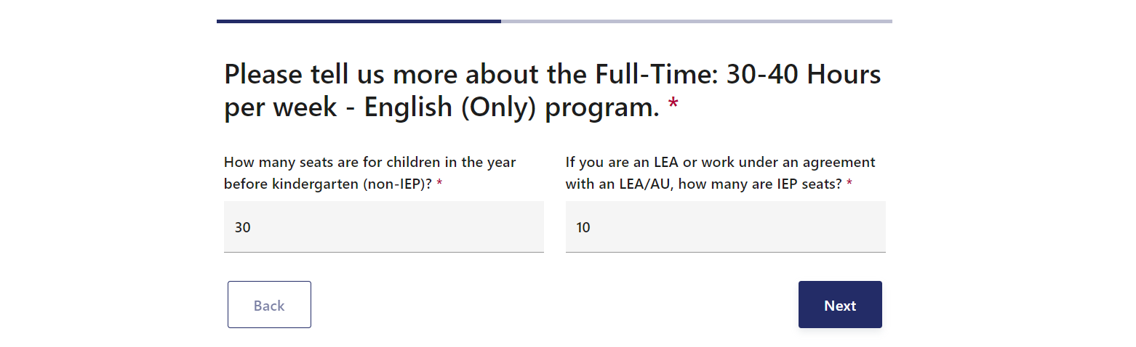

The “Full-Time: 30-40 Hours per week - Native Spanish (Only)” program has 18 non-IEP seats, and 2 IEP seats.

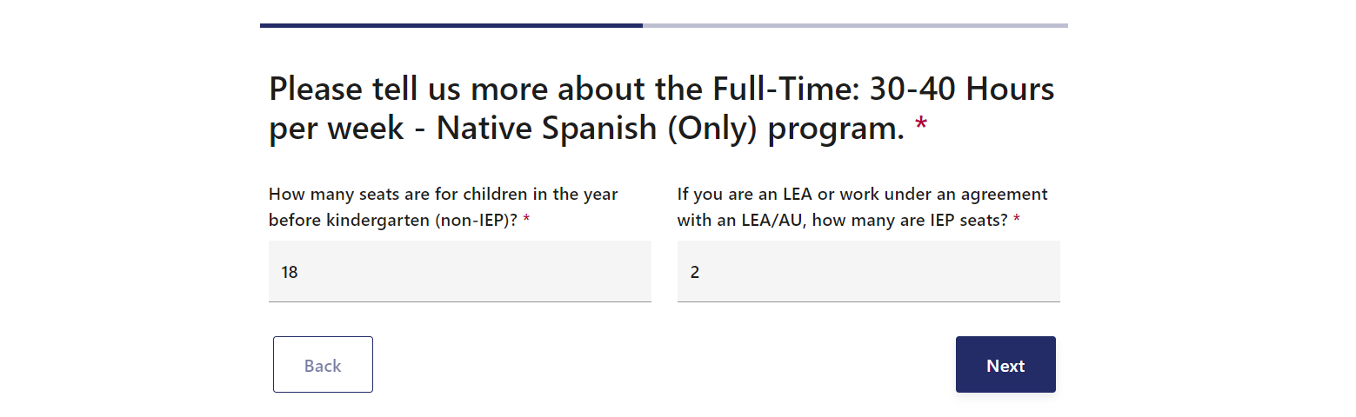

This completes the questions associated with “Full-Time: 30-40 Hours per week” programs. Next, we will move on to “Half-Day AM: 15 hours per week” program selection, starting with the Language of Instruction screen. This location offers two “Half-Day AM: 15 Hours per week” programs, one in “Other Native Language (Only)” instruction, and another for “Dual Language (English and Other Language)” Instruction. These selections are reflected in the screenshot below:

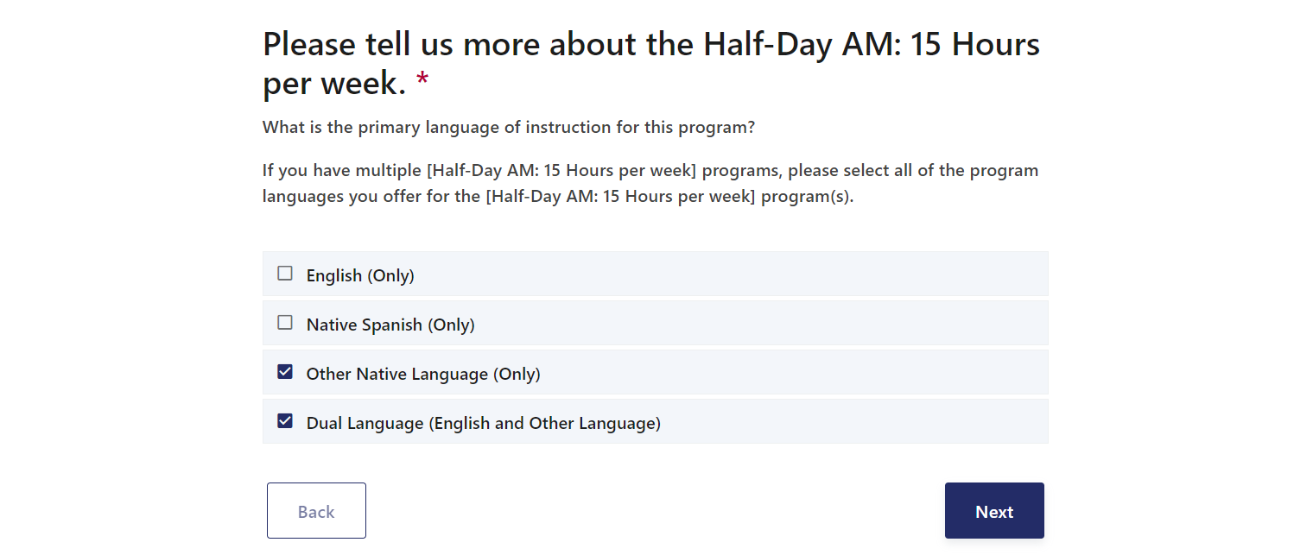

Next, Based on the combination of Program Durations and Language of Instruction, we will add the number of seats for each program.

The “Half-Day AM: 15 hours per week - Other Native Language (Only)” program has 18 non-IEP seats, and 2 IEP seats.

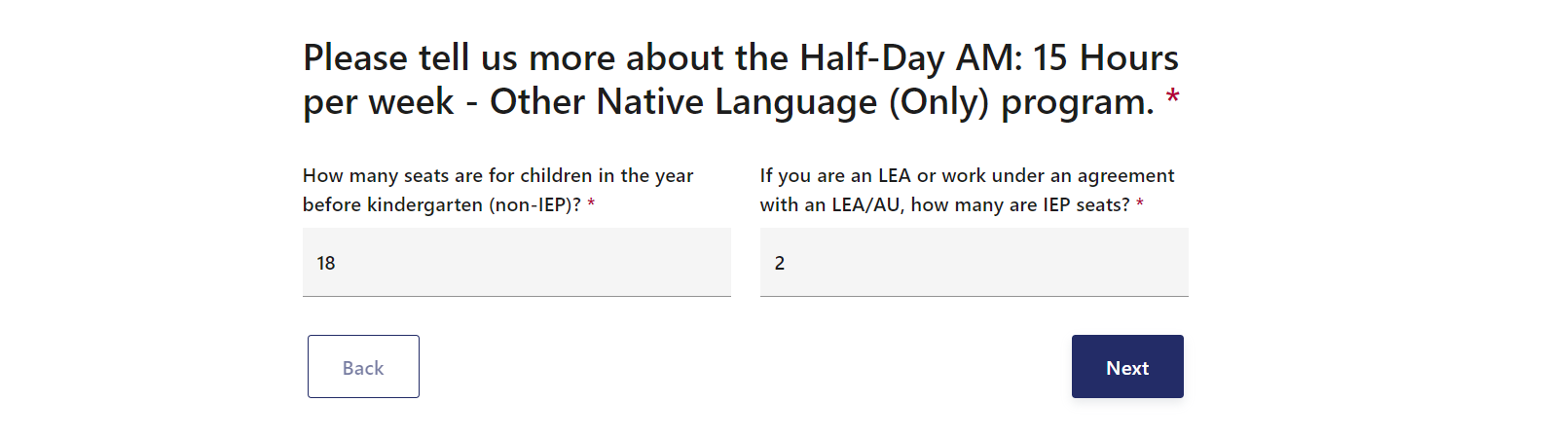

The “Half-Day AM: 15 hours per week - Dual Language (English and Other Language)” program has 18 non-IEP seats, and 2 IEP seats.

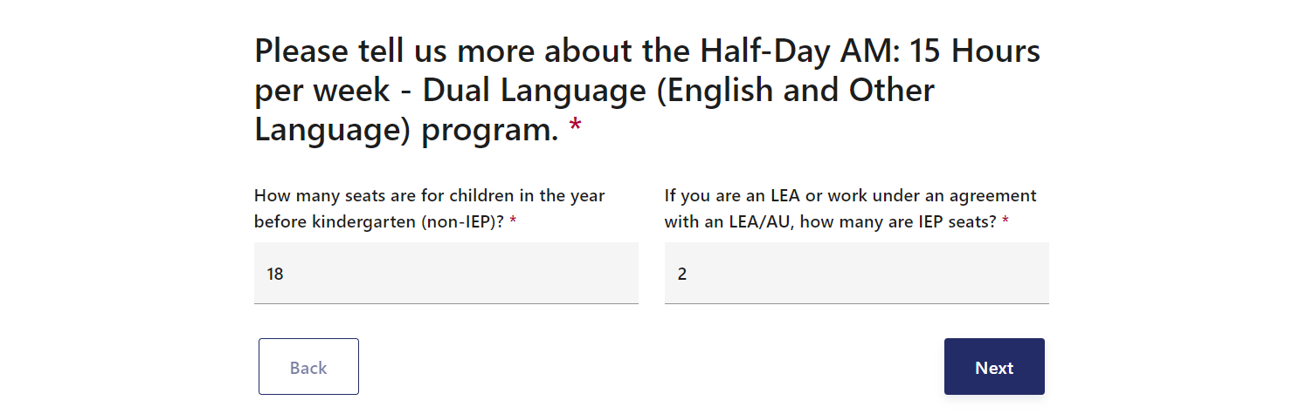

This completes the questions associated with “Half-Day AM: 15 Hours per week” programs. Next, we will move on to “Other: 18 Hours per week” program selections, starting with the Language of Instruction screen. This location offers only one language of instruction, English (Only). This selection is reflected in the screenshot below:

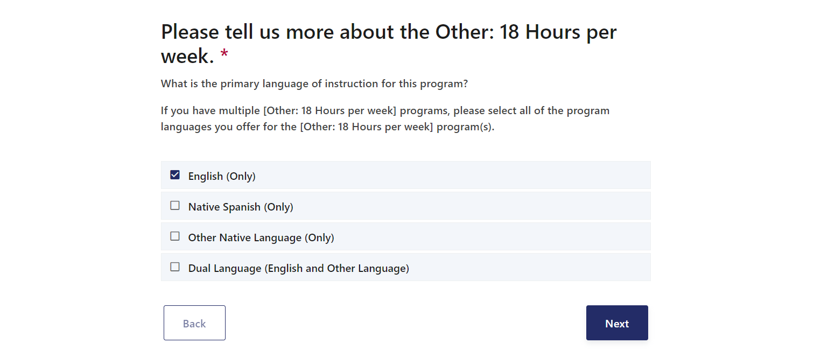

Based on the combination of Program Durations and Language of Instruction, we will add the number of seats for this program.

The “Other: 18 Hours per week - English (Only)” program has 13 non-IEP seats, and 6 IEP seats.

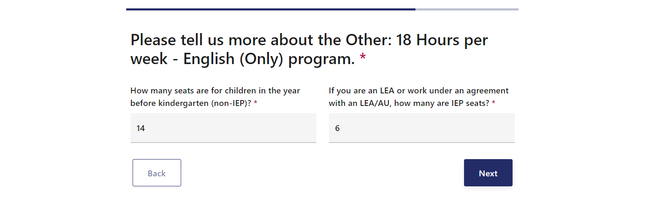

This completes the Program Set Up Form Program Details! There are a few more questions to complete this Program Set Up Form. The next question asks for the provider to attest to serve the total number of seats indicated in this form.

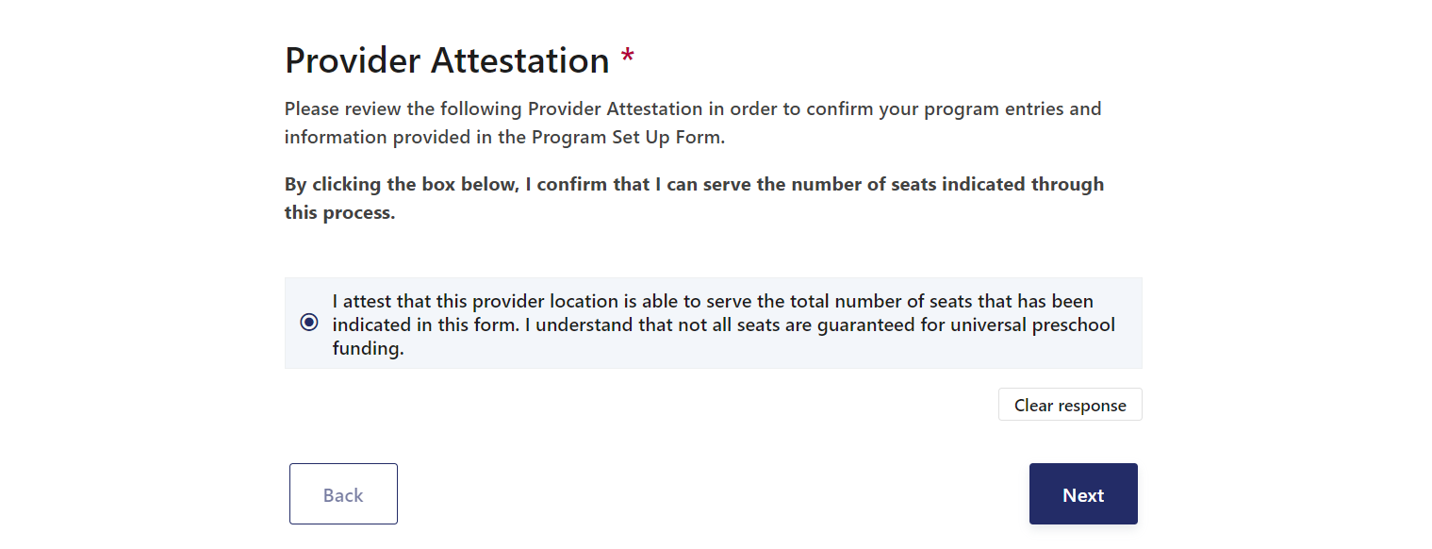

## **4. Indicate the Authorized Signer for the location we are setting up**

After completing the Program Details, the system is asking the user to list the Authorized Representatives first and last name, email address, as well as phone number, and indicate if this licensed provider is a single location or part of a larger entity. This information helps the program team understand where to send the Provider Agreement, and if the Provider Agreement is used for one or multiple locations.

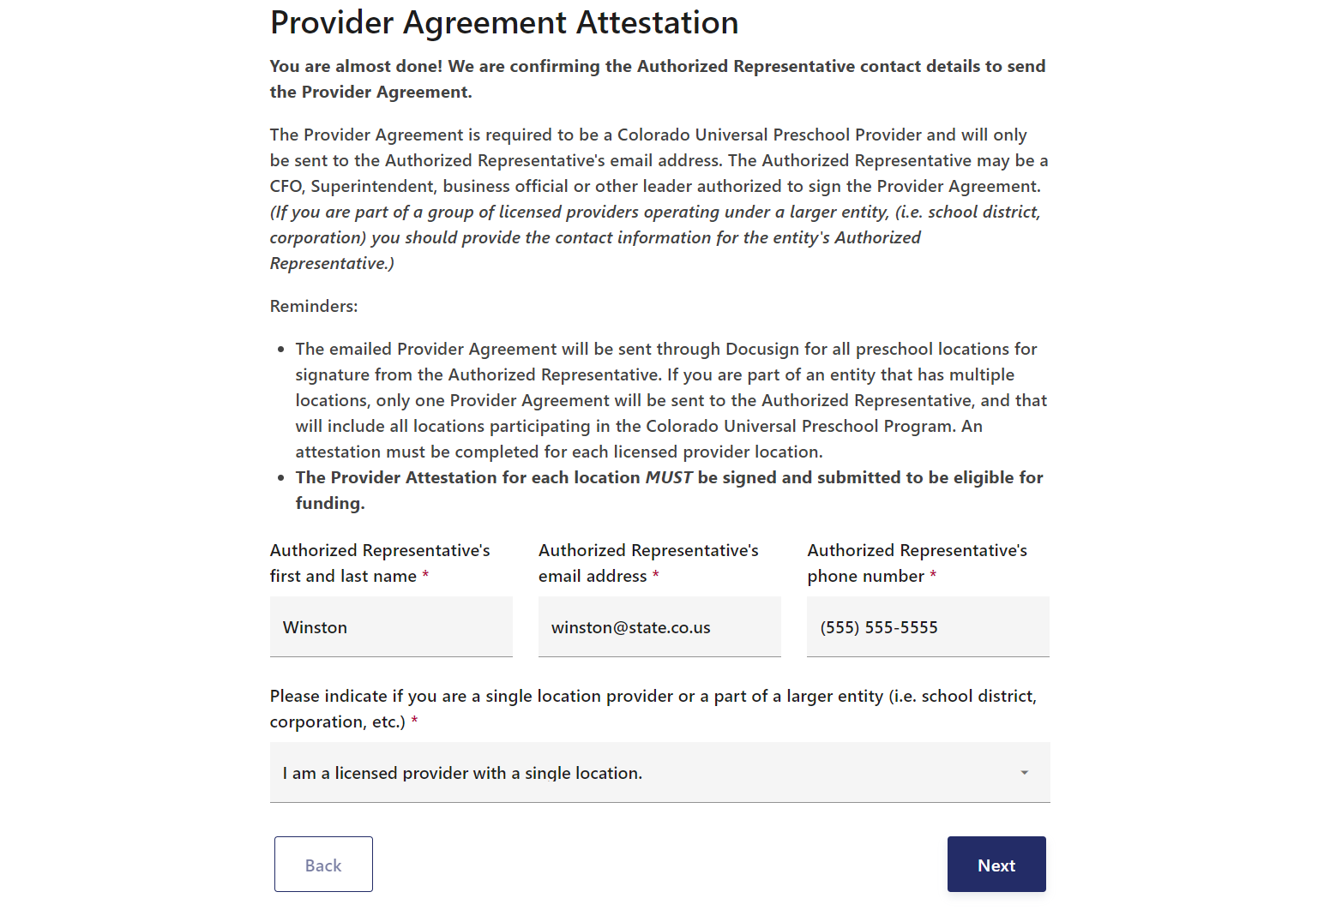

## **5. Understand the Next Steps after submitting the form**

Before submission we list the below next steps and resources - the critical next step is for the LCO to review and verify the completed Program Set Up Form. The LCO verification will load completed Provider Program Set Up Forms to the Family Portal for as long as this Provider Program Set Up Form is live.

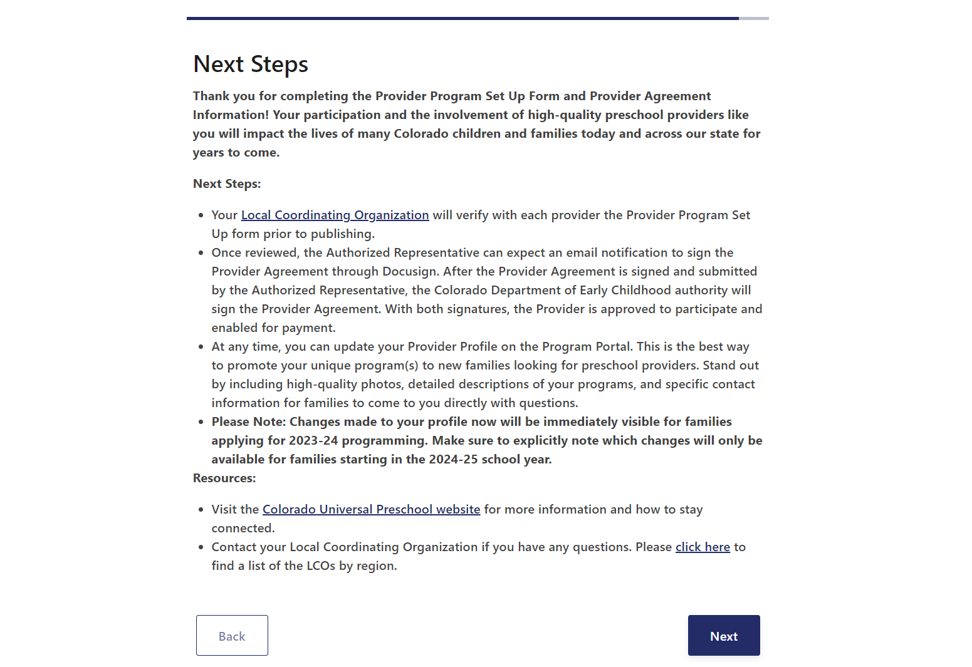

The final step is to click “Confirm and submit”, which completes this Provider Program Set Up Form.



## **Thank you for completing this form!**

As a reminder, the LCO will review and verify this form. If changes are needed to edit the form responses after submission, the LCO can review and edit the Provider Program Set Up Form. When the LCO edits and saves form responses, Providers can click the “Review” button (available after the form is submitted) to validate the changes are correct with new answers to questions.

## 

## 

## 

For additional questions, please contact your LCO or attend Provider Office Hours held at the end of January.

