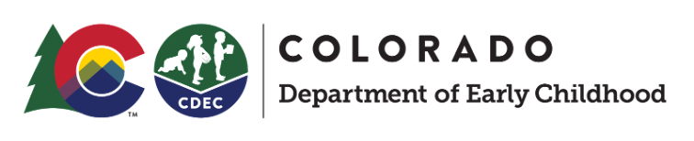

# Online Application System

## Match and Enrollment Portal for Providers

Version 1.0

Need Help?

For help with the Match and Enrollment Portal for Providers:

* Email (LCO)
* Call (LCO)

Questions/Support related to UPK policies and guidance:

* Contact #1 (LCO)
* Contact #2

Portal Link/URL

This link should be bookmarked for quick access from your browser:

* Sign in Page:<https://providers.upk.colorado.gov>

Managing Student Status

## Viewing multiple program years

From the Locations dashboard, you will see three columns displaying the number of Placements Made, Placements Accepted, and Placement - Awaiting Family Response students.

Using the selector at the top of the page you can switch between program years. For example, changing the year to 2022-2023 Preschool for All will display the total children within each status for that program year.

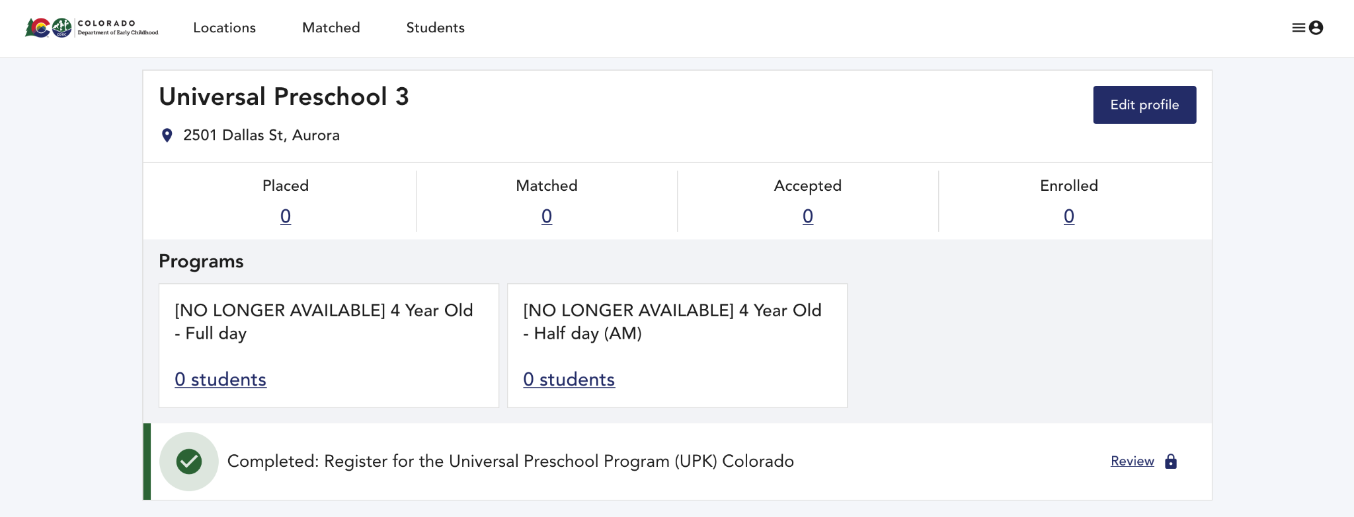

You can click on any of these numbers to view a list of all students with that status. The lists of Matched and Enrolled students can also be accessed in the navigation at the top of the page.

## Statuses

You will see the following statuses within the Online Application System:

|  |  |
| --- | --- |
| Status | Description |
| Placed | Placement is shared with provider for the provider review period. Family is not yet notified. |
| Matched | Family notified of the match. Provider can contact family to share program information and answer questions. |
| Accepted | Family accepts the match. Provider should contact family with instructions for enrolling. |
| Enrolled | All enrollment documents are completed, including UPK’s enrollment form. |

Note: If a family declines their match at your location, the child’s record will be removed from your provider portal.

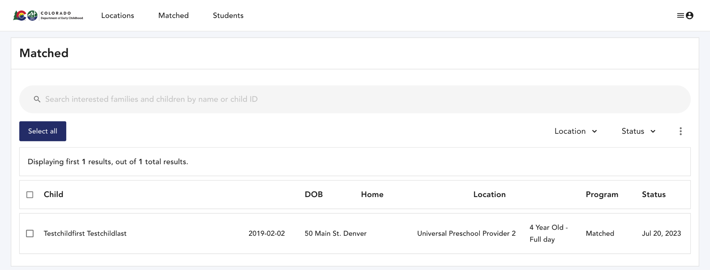

## Enrolling a child

You will only be able to confirm enrollment for children whose placement offers have been accepted. The status must be “Accepted”.

To confirm enrollment for a student, you’ll need to click on their name in the list. A pop-up will display the child’s name and birthdate, along with the date they were placed. To change their status to Enrolled, click on the dropdown below the date and click the green “Enrolled” button.

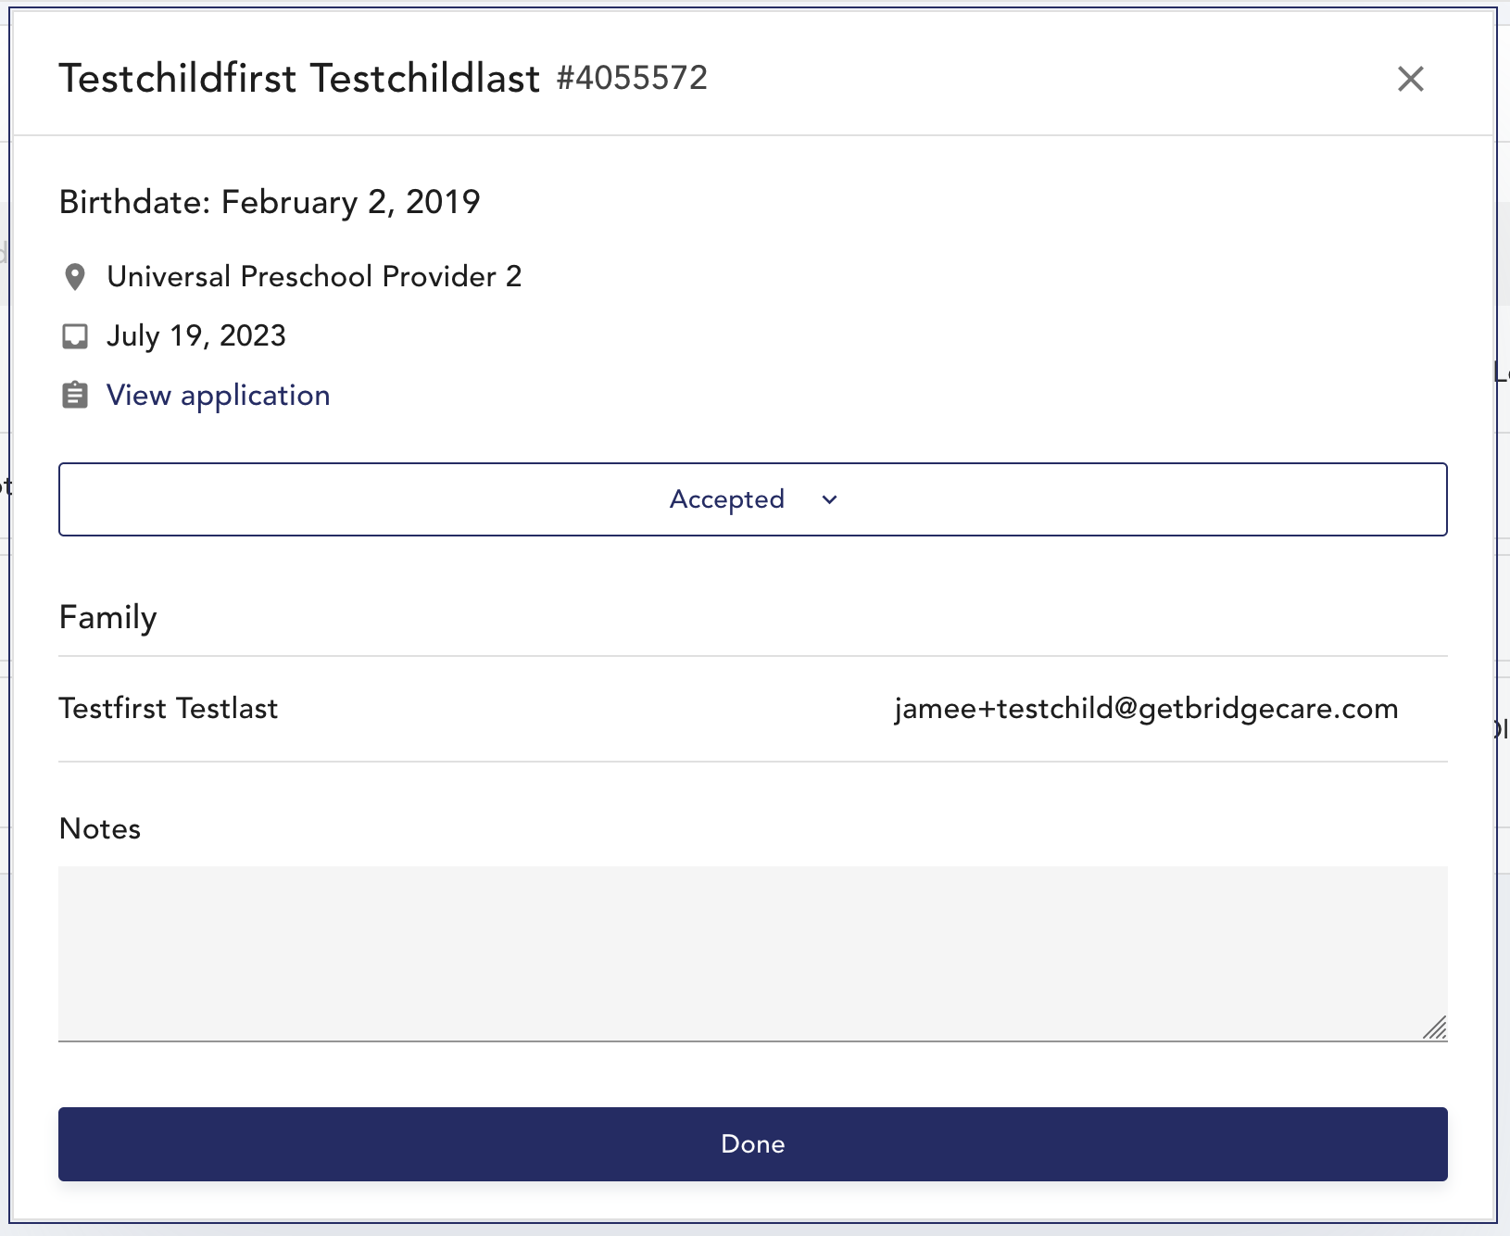

Once a family has accepted placement, the only option you will have is to Enroll the child using the “Enrolled” button

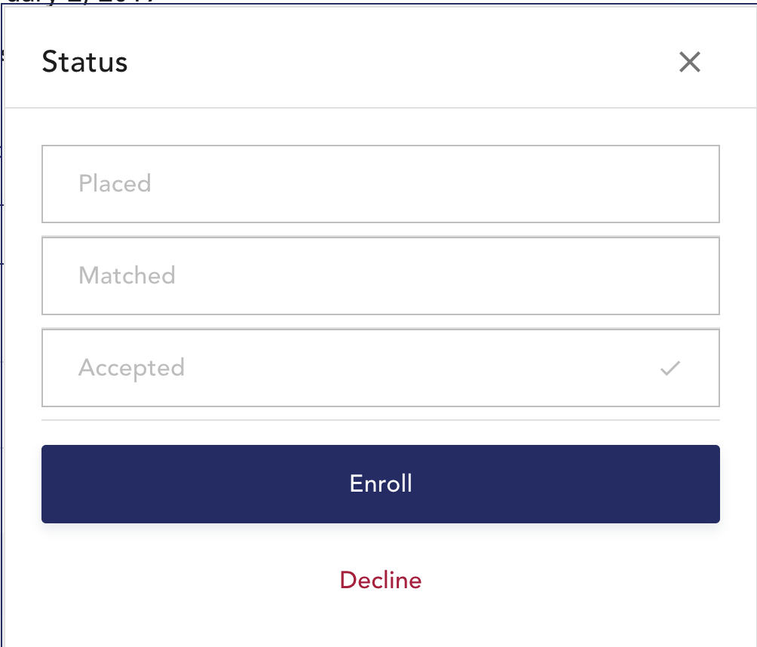

Then, select the location where the student will be Enrolled, and use the date dropdown to enter the date the child will start attending. If you only manage one location, only one location will be available to select from the dropdown list.

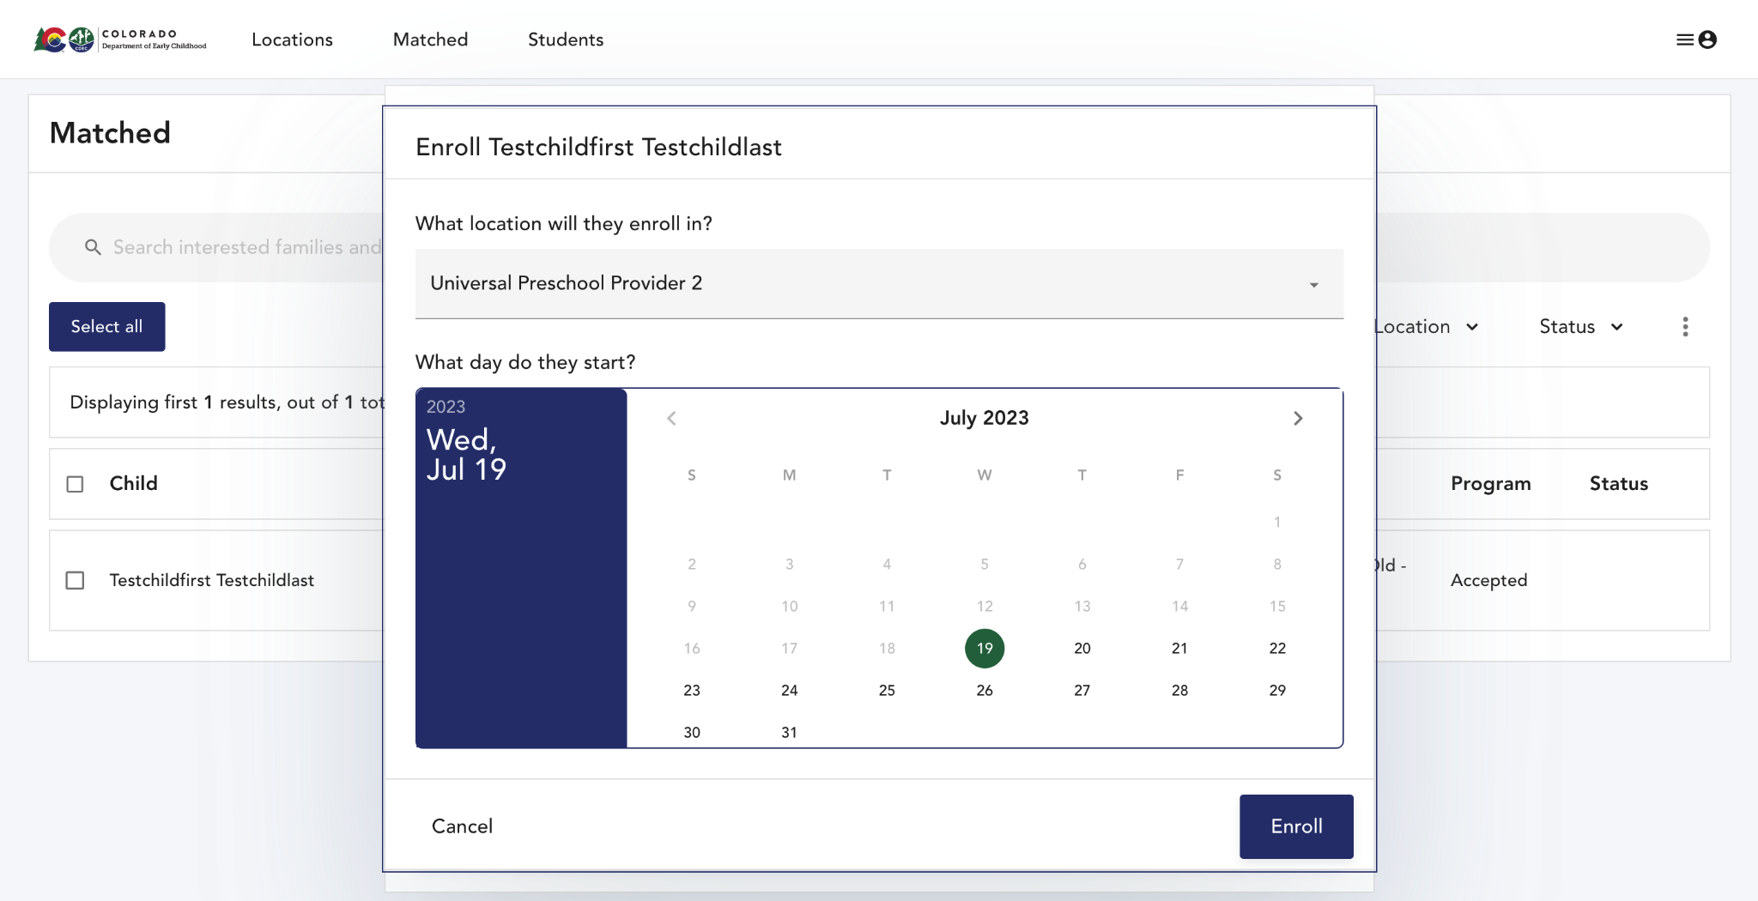

Confirm that the enrollment requirements have been completed, and that eligibility documentation has been verified.

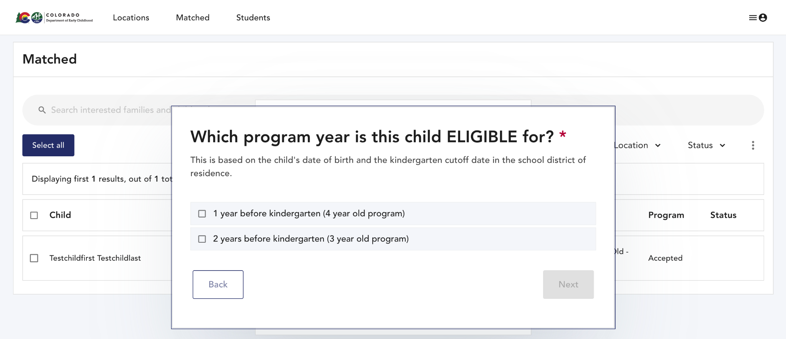

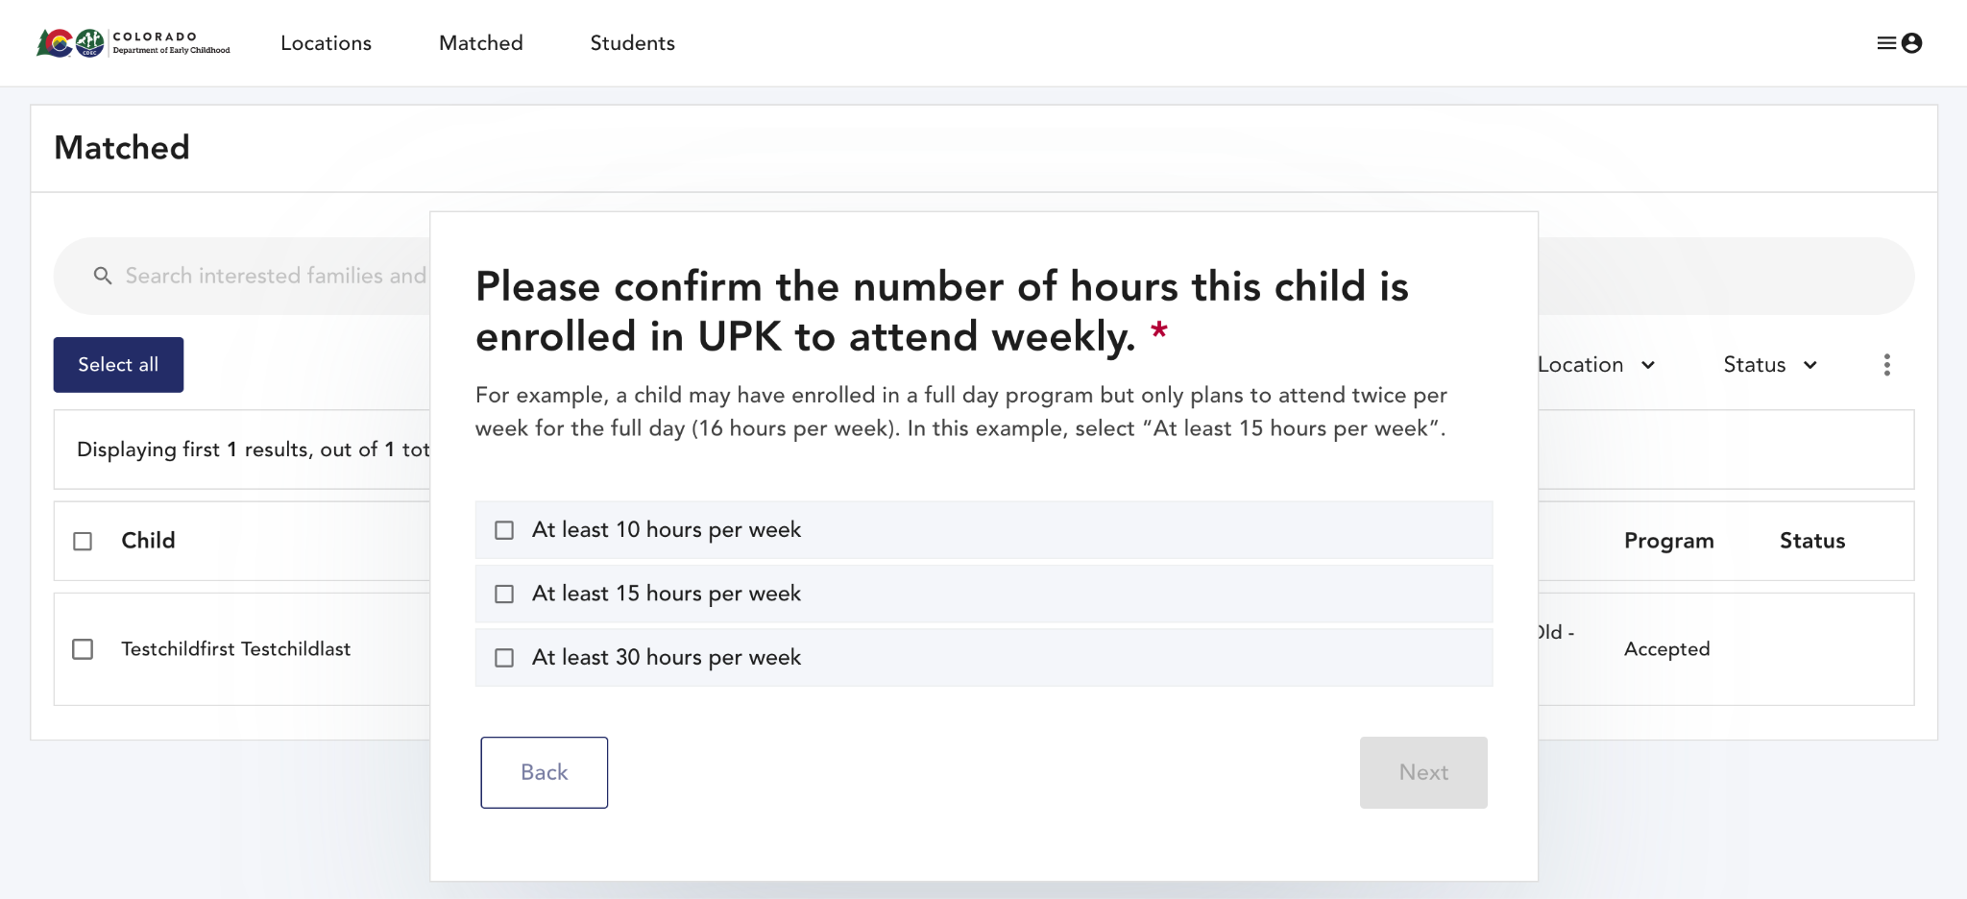

The provider will indicate whether the child participates in Head Start, CCCAP, and/or has an IEP. If the information is unknown, click “Unsure”

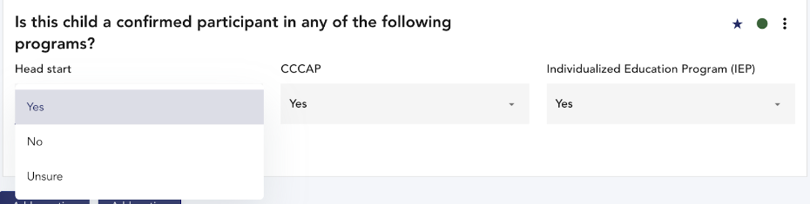

## Unenrolling a child

IMPORTANT:

● When you unenroll a child from your program using these instructions, you will no longer see the child’s record in your Provider Portal.

● When you unenroll a child from your program, the seat will be immediately open for

UPK to fill. Unenroll a child only when they are no longer attending.

● If you have questions about UPK’s policies related to when to unenroll a child, contact

cdec_upkcolorado@state.co.us

● If you confirmed enrollment for a child by mistake (i.e. enrollment was not actually

completed for the child), do NOT use this function to correct the mistake. Contact

cdec_upkcolorado@state.co.us to correct the mistake.

Instructions

If you need to unenroll a student, click on “Enrolled” in the top navigation bar. Click on a student’s name, scroll to the bottom of the pop-up, and click on the red text that says “Unenroll student.”

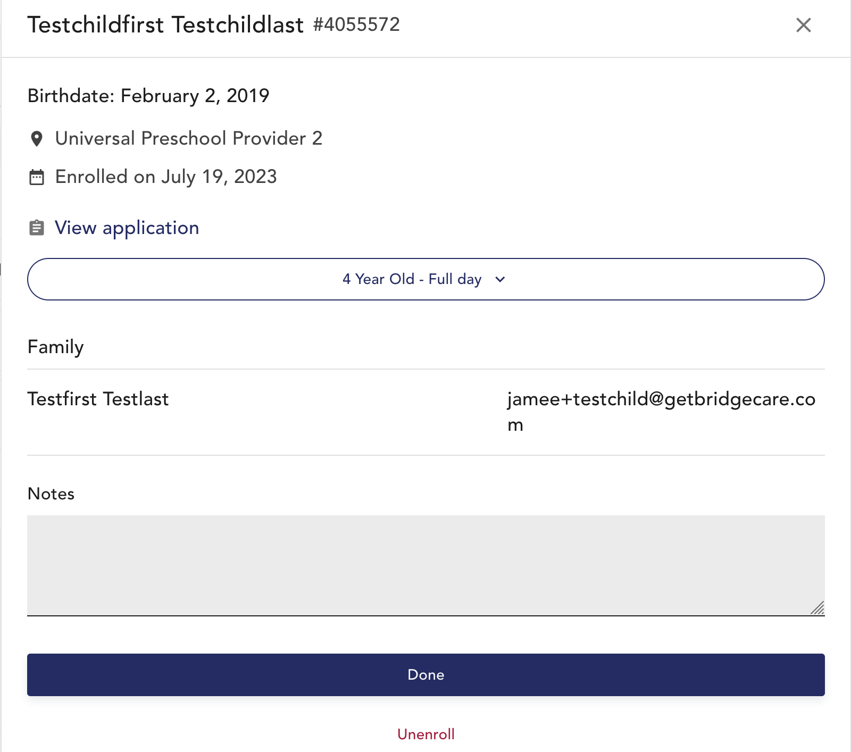

You will see another pop-up that asks you to confirm unenrollment. Click OK and select the reason for unenrollment.